**DMDD Final Project – Rental Property Management System**

**Purpose:**

This project aims to create a data model and design a complete database for rental property management system. It aims to cover the whole business model of a rental property management system which deals with different users who are going to use this database.

**Approach:**

I have followed **Forward Engineering approach** and designed EER model diagram first by defining tables and their attributes, established relationships and database objects like tables schema is populated.

Here is the below approach to design an EER model 🡪

1. **Building Details table** – Consists of details of different buildings in the vicinity or on a street.
2. **Unit Details table** – consists of details of the unit like unit number, resident id, no of bedrooms, no of washrooms, pet allowed, in unit laundry facility available.
3. **Staff Table** – Management Staff and Maintenance Staff are responsible for overall management of units in respective buildings. Management staff takes care of lease details, payments, inspection checks and maintenance requests logged, if any. Maintenance Staff is responsible for servicing or repairing items found during maintenance requests logged or during inspection checks.
4. **Appointment schedules** – Residents can schedule an appointment with management staff for either logging maintenance requests or any other inquiries/concerns they have during the stay.
5. **Inspection checks** – This table is designed to serve the purpose that all inspection checks are tracked and if any observation is found then they can be used for corrections or warnings to be given to residents.
6. **Maintenance Requests** – This table helps to keep track of maintenance requests logged and ensure that they are being serviced by the maintenance staff on time.
7. **Lease Details:** It keeps a track of lease details agreed between management company and resident Id. It has attributes like lease id, lease term, lease start and end date etc.
8. **Lease Payment Details**: This helps in keeping track of payment details such as monthly rent, deposit, pet deposit, total payment amount etc.
9. **Security deposit returns:** This helps in keeping track of expired leases and management company is now responsible for repayment of security deposits which they took from the residents during the start of the lease.
10. **Role Table:** This defines different roles of people here.

Here is the first draft of the EER diagram drawn.

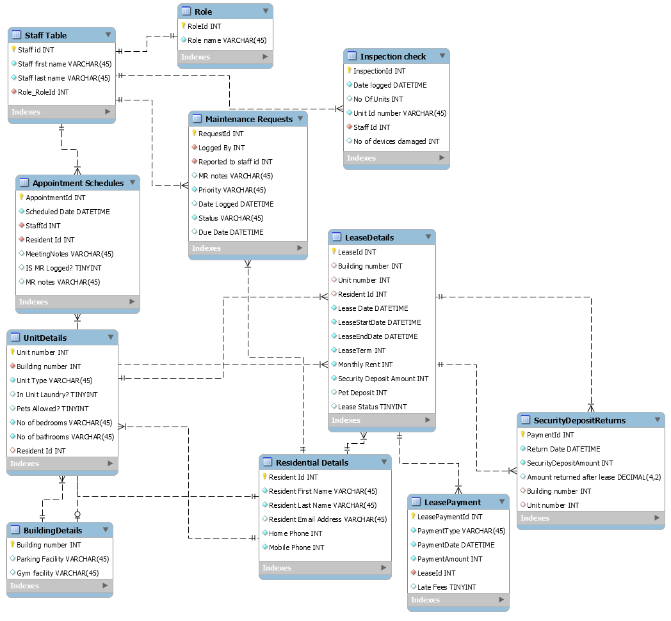

Here is the final and normalized EER model diagram:

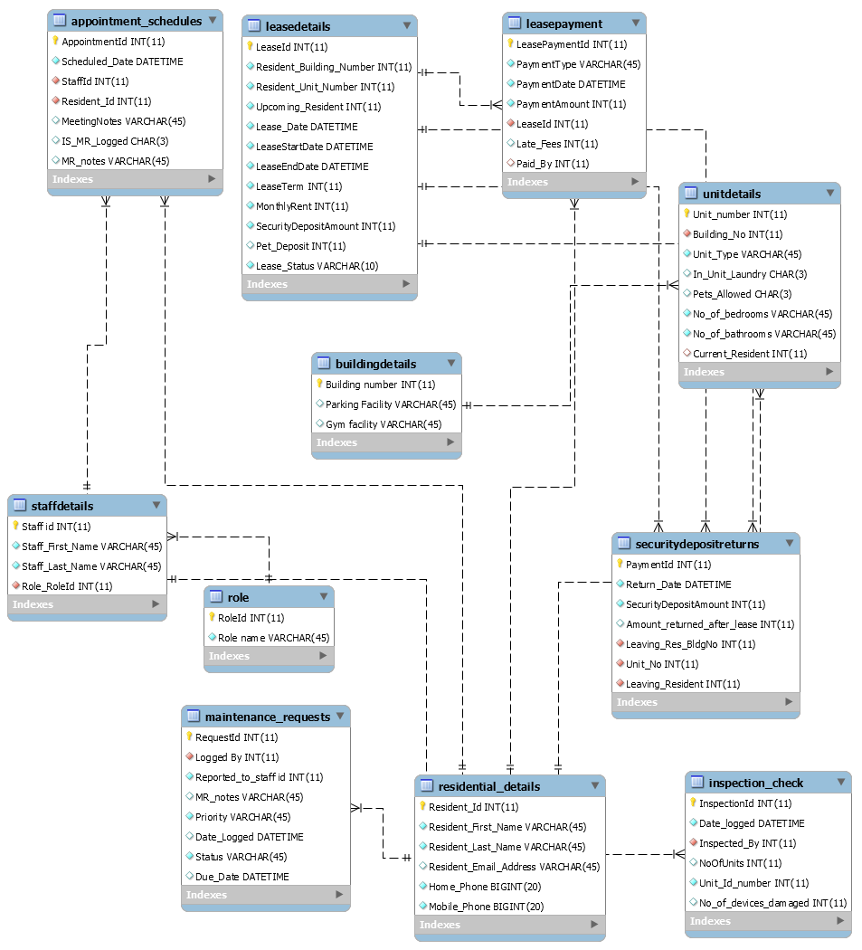

**Database Objects:**

1. Tables – This has been described above.
2. Views –

**viewLeaseDetails :** This view helps in seeing all the lease and lease payment details.

**viewResidentialDetails :** This view helps in viewing Residential Data

1. Functions – **calculateTotalAmount()**. This function helps in determining total amount received by management staff for the lease.
2. Stored Procedures – **usp_AddDatatoSecurityDepositReturns()**
3. Triggers –

**negative_value :** This trigger helps in validating the data for negative values entered on number of bedrooms in LeaseDetails table.

**negative_value_bathrooms :** This trigger helps in validating the data for negative values entered on number of bathrooms in LeaseDetails table.

1. Transactions – **transactionView**

**Users :**

1. **User 1:** This user is part of management staff who can login and check maintenance requests logged, appointment schedules, inspection checks.
2. **User 2 :** This user is part of maintenance staff who can check maintenance requests.
3. **User 3 :** This is a resident staying in that locality. They can login and check all the details related to them and maintenance requests logged by them.

**SQL dumps :**

CREATE DATABASE IF NOT EXISTS `propertymanagementdatabase` /*!40100 DEFAULT CHARACTER SET utf8 */;

USE `propertymanagementdatabase`;

-- MySQL dump 10.13 Distrib 8.0.12, for Win64 (x86_64)

--

-- Host: localhost Database: propertymanagementdatabase

-- ------------------------------------------------------

-- Server version 8.0.12

/*!40101 SET @OLD_CHARACTER_SET_CLIENT=@@CHARACTER_SET_CLIENT */;

/*!40101 SET @OLD_CHARACTER_SET_RESULTS=@@CHARACTER_SET_RESULTS */;

/*!40101 SET @OLD_COLLATION_CONNECTION=@@COLLATION_CONNECTION */;

SET NAMES utf8 ;

/*!40103 SET @OLD_TIME_ZONE=@@TIME_ZONE */;

/*!40103 SET TIME_ZONE='+00:00' */;

/*!40014 SET @OLD_UNIQUE_CHECKS=@@UNIQUE_CHECKS, UNIQUE_CHECKS=0 */;

/*!40014 SET @OLD_FOREIGN_KEY_CHECKS=@@FOREIGN_KEY_CHECKS, FOREIGN_KEY_CHECKS=0 */;

/*!40101 SET @OLD_SQL_MODE=@@SQL_MODE, SQL_MODE='NO_AUTO_VALUE_ON_ZERO' */;

/*!40111 SET @OLD_SQL_NOTES=@@SQL_NOTES, SQL_NOTES=0 */;

--

-- Table structure for table `appointment_schedules`

--

DROP TABLE IF EXISTS `appointment_schedules`;

/*!40101 SET @saved_cs_client = @@character_set_client */;

SET character_set_client = utf8mb4 ;

CREATE TABLE `appointment_schedules` (

`AppointmentId` int(11) NOT NULL AUTO_INCREMENT,

`Scheduled_Date` datetime NOT NULL,

`StaffId` int(11) NOT NULL,

`Resident_Id` int(11) NOT NULL,

`MeetingNotes` varchar(45) DEFAULT NULL,

`IS_MR_Logged` char(3) DEFAULT NULL,

`MR_notes` varchar(45) DEFAULT NULL,

PRIMARY KEY (`AppointmentId`),

KEY `Staff Id_idx` (`StaffId`),

KEY `Resident Id_idx` (`Resident_Id`),

CONSTRAINT `Resident Id` FOREIGN KEY (`Resident_Id`) REFERENCES `residential_details` (`resident_id`),

CONSTRAINT `Staff Id` FOREIGN KEY (`StaffId`) REFERENCES `staffdetails` (`staff id`)

) ENGINE=InnoDB AUTO_INCREMENT=11 DEFAULT CHARSET=utf8;

/*!40101 SET character_set_client = @saved_cs_client */;

--

-- Dumping data for table `appointment_schedules`

--

LOCK TABLES `appointment_schedules` WRITE;

/*!40000 ALTER TABLE `appointment_schedules` DISABLE KEYS */;

/*!40000 ALTER TABLE `appointment_schedules` ENABLE KEYS */;

UNLOCK TABLES;

--

-- Table structure for table `buildingdetails`

--

DROP TABLE IF EXISTS `buildingdetails`;

/*!40101 SET @saved_cs_client = @@character_set_client */;

SET character_set_client = utf8mb4 ;

CREATE TABLE `buildingdetails` (

`Building number` int(11) NOT NULL,

`Parking Facility` varchar(45) DEFAULT NULL,

`Gym facility` varchar(45) DEFAULT NULL,

PRIMARY KEY (`Building number`)

) ENGINE=InnoDB DEFAULT CHARSET=utf8;

/*!40101 SET character_set_client = @saved_cs_client */;

--

-- Dumping data for table `buildingdetails`

--

LOCK TABLES `buildingdetails` WRITE;

/*!40000 ALTER TABLE `buildingdetails` DISABLE KEYS */;

INSERT INTO `buildingdetails` VALUES (1,'Parking available','Gym available'),(2,'Parking available','Gym not available'),(3,'Parking available','Gym not available'),(4,'Parking available','Gym not available'),(5,'Parking available','Gym not available'),(6,'Parking available','Gym available'),(7,'Street parking','Gym not available'),(8,'Street Parking','Gym not available'),(9,'Parking available','Gym not available'),(10,'Parking available','Gym available');

/*!40000 ALTER TABLE `buildingdetails` ENABLE KEYS */;

UNLOCK TABLES;

--

-- Table structure for table `inspection_check`

--

DROP TABLE IF EXISTS `inspection_check`;

/*!40101 SET @saved_cs_client = @@character_set_client */;

SET character_set_client = utf8mb4 ;

CREATE TABLE `inspection_check` (

`InspectionId` int(11) NOT NULL AUTO_INCREMENT,

`Date_logged` datetime NOT NULL,

`Inspected_By` int(11) NOT NULL,

`NoOfUnits` int(11) DEFAULT NULL,

`Unit_Id_number` int(11) NOT NULL,

`No_of_devices_damaged` int(11) DEFAULT NULL,

PRIMARY KEY (`InspectionId`),

UNIQUE KEY `Unit Id number_UNIQUE` (`Unit_Id_number`),

KEY `Staff Id_idx` (`Inspected_By`),

CONSTRAINT `Inspected_By` FOREIGN KEY (`Inspected_By`) REFERENCES `staffdetails` (`staff id`)

) ENGINE=InnoDB AUTO_INCREMENT=11 DEFAULT CHARSET=utf8;

/*!40101 SET character_set_client = @saved_cs_client */;

--

-- Dumping data for table `inspection_check`

--

LOCK TABLES `inspection_check` WRITE;

/*!40000 ALTER TABLE `inspection_check` DISABLE KEYS */;

/*!40000 ALTER TABLE `inspection_check` ENABLE KEYS */;

UNLOCK TABLES;

--

-- Table structure for table `leasedetails`

--

DROP TABLE IF EXISTS `leasedetails`;

/*!40101 SET @saved_cs_client = @@character_set_client */;

SET character_set_client = utf8mb4 ;

CREATE TABLE `leasedetails` (

`LeaseId` int(11) NOT NULL AUTO_INCREMENT,

`Resident_Building_Number` int(11) NOT NULL,

`Resident_Unit_Number` int(11) NOT NULL,

`Upcoming_Resident` int(11) NOT NULL,

`Lease_Date` datetime NOT NULL,

`LeaseStartDate` datetime NOT NULL,

`LeaseEndDate` datetime NOT NULL,

`LeaseTerm` int(11) NOT NULL,

`MonthlyRent` int(11) NOT NULL,

`SecurityDepositAmount` int(11) NOT NULL,

`Pet_Deposit` int(11) DEFAULT NULL,

`Lease_Status` varchar(10) NOT NULL,

PRIMARY KEY (`LeaseId`),

KEY `Resident Id_idx` (`Upcoming_Resident`),

KEY `Building number_idx` (`Resident_Building_Number`),

KEY `Unit number_idx` (`Resident_Unit_Number`)

) ENGINE=InnoDB AUTO_INCREMENT=14 DEFAULT CHARSET=utf8;

/*!40101 SET character_set_client = @saved_cs_client */;

--

-- Dumping data for table `leasedetails`

--

LOCK TABLES `leasedetails` WRITE;

/*!40000 ALTER TABLE `leasedetails` DISABLE KEYS */;

INSERT INTO `leasedetails` VALUES (7,1,1,1,'2018-09-01 00:00:00','2018-09-01 00:00:00','2019-08-31 00:00:00',12,2250,2250,0,'Active'),(8,1,1,2,'2018-09-01 00:00:00','2018-09-01 00:00:00','2019-08-31 00:00:00',12,2250,2250,0,'Active'),(9,1,2,3,'2018-09-01 00:00:00','2018-09-01 00:00:00','2019-08-31 00:00:00',12,2250,2250,0,'Active'),(10,1,2,4,'2018-09-01 00:00:00','2018-09-01 00:00:00','2019-08-31 00:00:00',12,2250,2250,0,'Active'),(11,1,3,2,'2018-09-01 00:00:00','2018-09-01 00:00:00','2019-08-31 00:00:00',12,2500,2500,100,'Active'),(12,2,3,5,'2018-12-11 00:00:00','2019-01-01 00:00:00','2020-12-31 00:00:00',12,2700,2700,150,'Active'),(13,2,3,6,'2018-12-11 00:00:00','2017-01-01 00:00:00','2018-06-30 00:00:00',6,2700,2700,150,'Expired');

/*!40000 ALTER TABLE `leasedetails` ENABLE KEYS */;

UNLOCK TABLES;

--

-- Table structure for table `leasepayment`

--

DROP TABLE IF EXISTS `leasepayment`;

/*!40101 SET @saved_cs_client = @@character_set_client */;

SET character_set_client = utf8mb4 ;

CREATE TABLE `leasepayment` (

`LeasePaymentId` int(11) NOT NULL AUTO_INCREMENT,

`PaymentType` varchar(45) NOT NULL,

`PaymentDate` datetime NOT NULL,

`PaymentAmount` int(11) NOT NULL,

`LeaseId` int(11) NOT NULL,

`Late_Fees` int(11) DEFAULT NULL,

`Paid_By` int(11) DEFAULT NULL,

PRIMARY KEY (`LeasePaymentId`),

KEY `LeaseId_idx` (`LeaseId`),

KEY `Paid By_idx` (`Paid_By`),

CONSTRAINT `Lease Id` FOREIGN KEY (`LeaseId`) REFERENCES `leasedetails` (`leaseid`),

CONSTRAINT `Paid By` FOREIGN KEY (`Paid_By`) REFERENCES `residential_details` (`resident_id`)

) ENGINE=InnoDB AUTO_INCREMENT=12 DEFAULT CHARSET=utf8;

/*!40101 SET character_set_client = @saved_cs_client */;

--

-- Dumping data for table `leasepayment`

--

LOCK TABLES `leasepayment` WRITE;

/*!40000 ALTER TABLE `leasepayment` DISABLE KEYS */;

/*!40000 ALTER TABLE `leasepayment` ENABLE KEYS */;

UNLOCK TABLES;

--

-- Table structure for table `maintenance_requests`

--

DROP TABLE IF EXISTS `maintenance_requests`;

/*!40101 SET @saved_cs_client = @@character_set_client */;

SET character_set_client = utf8mb4 ;

CREATE TABLE `maintenance_requests` (

`RequestId` int(11) NOT NULL AUTO_INCREMENT,

`Logged By` int(11) NOT NULL,

`Reported_to_staff id` int(11) NOT NULL,

`MR_notes` varchar(45) DEFAULT NULL,

`Priority` varchar(45) NOT NULL,

`Date_Logged` datetime DEFAULT NULL,

`Status` varchar(45) NOT NULL,

`Due_Date` datetime DEFAULT NULL,

PRIMARY KEY (`RequestId`),

KEY `Reported to Staff id_idx` (`Reported_to_staff id`),

KEY `Logged By Resident Id_idx` (`Logged By`),

CONSTRAINT `Logged By Resident Id` FOREIGN KEY (`Logged By`) REFERENCES `residential_details` (`resident_id`)

) ENGINE=InnoDB DEFAULT CHARSET=utf8;

/*!40101 SET character_set_client = @saved_cs_client */;

--

-- Dumping data for table `maintenance_requests`

--

LOCK TABLES `maintenance_requests` WRITE;

/*!40000 ALTER TABLE `maintenance_requests` DISABLE KEYS */;

/*!40000 ALTER TABLE `maintenance_requests` ENABLE KEYS */;

UNLOCK TABLES;

--

-- Table structure for table `residential_details`

--

DROP TABLE IF EXISTS `residential_details`;

/*!40101 SET @saved_cs_client = @@character_set_client */;

SET character_set_client = utf8mb4 ;

CREATE TABLE `residential_details` (

`Resident_Id` int(11) NOT NULL AUTO_INCREMENT,

`Resident_First_Name` varchar(45) NOT NULL,

`Resident_Last_Name` varchar(45) NOT NULL,

`Resident_Email_Address` varchar(45) DEFAULT NULL,

`Home_Phone` bigint(20) NOT NULL,

`Mobile_Phone` bigint(20) NOT NULL,

PRIMARY KEY (`Resident_Id`)

) ENGINE=InnoDB AUTO_INCREMENT=11 DEFAULT CHARSET=utf8;

/*!40101 SET character_set_client = @saved_cs_client */;

--

-- Dumping data for table `residential_details`

--

LOCK TABLES `residential_details` WRITE;

/*!40000 ALTER TABLE `residential_details` DISABLE KEYS */;

INSERT INTO `residential_details` VALUES (6,'Ashmita','Nigam','ashmitan@gmail.com',9,90),(7,'Ria','Rajput','rrajput@hotmail.com',9920055780,9867227460),(8,'Jessica','Simpson','jsimpson@hotmail.com',8572631098,8572891100),(9,'Wang','Wei','wangwei@yahoo.com',8761234980,866690056),(10,'Jennifer','Goddard','jenniferg@gmail.com',7074119097,7074119097);

/*!40000 ALTER TABLE `residential_details` ENABLE KEYS */;

UNLOCK TABLES;

--

-- Table structure for table `role`

--

DROP TABLE IF EXISTS `role`;

/*!40101 SET @saved_cs_client = @@character_set_client */;

SET character_set_client = utf8mb4 ;

CREATE TABLE `role` (

`RoleId` int(11) NOT NULL,

`Role name` varchar(45) NOT NULL,

PRIMARY KEY (`RoleId`)

) ENGINE=InnoDB DEFAULT CHARSET=utf8;

/*!40101 SET character_set_client = @saved_cs_client */;

--

-- Dumping data for table `role`

--

LOCK TABLES `role` WRITE;

/*!40000 ALTER TABLE `role` DISABLE KEYS */;

INSERT INTO `role` VALUES (1,'Management Staff'),(2,'Maintenance Staff');

/*!40000 ALTER TABLE `role` ENABLE KEYS */;

UNLOCK TABLES;

--

-- Table structure for table `securitydepositreturns`

--

DROP TABLE IF EXISTS `securitydepositreturns`;

/*!40101 SET @saved_cs_client = @@character_set_client */;

SET character_set_client = utf8mb4 ;

CREATE TABLE `securitydepositreturns` (

`PaymentId` int(11) NOT NULL AUTO_INCREMENT,

`Return_Date` datetime NOT NULL,

`SecurityDepositAmount` int(11) NOT NULL,

`Amount_returned_after_lease` int(11) DEFAULT NULL,

`Leaving_Res_BldgNo` int(11) NOT NULL,

`Unit_No` int(11) NOT NULL,

`Leaving_Resident` int(11) NOT NULL,

PRIMARY KEY (`PaymentId`),

KEY `Building number_idx` (`Leaving_Res_BldgNo`),

KEY `Unit number_idx` (`Unit_No`),

KEY `Leaving Resident_idx` (`Leaving_Resident`),

CONSTRAINT `Leaving Resident` FOREIGN KEY (`Leaving_Resident`) REFERENCES `leasedetails` (`upcoming_resident`),

CONSTRAINT `Resident Bldg No` FOREIGN KEY (`Leaving_Res_BldgNo`) REFERENCES `leasedetails` (`resident_building_number`),

CONSTRAINT `Resident Unit No` FOREIGN KEY (`Unit_No`) REFERENCES `leasedetails` (`resident_unit_number`)

) ENGINE=InnoDB AUTO_INCREMENT=5 DEFAULT CHARSET=utf8;

/*!40101 SET character_set_client = @saved_cs_client */;

--

-- Dumping data for table `securitydepositreturns`

--

LOCK TABLES `securitydepositreturns` WRITE;

/*!40000 ALTER TABLE `securitydepositreturns` DISABLE KEYS */;

INSERT INTO `securitydepositreturns` VALUES (3,'2018-08-31 00:00:00',2500,2450,2,3,6),(4,'2018-01-02 10:00:00',2000,1500,1,1,1);

/*!40000 ALTER TABLE `securitydepositreturns` ENABLE KEYS */;

UNLOCK TABLES;

--

-- Table structure for table `staffdetails`

--

DROP TABLE IF EXISTS `staffdetails`;

/*!40101 SET @saved_cs_client = @@character_set_client */;

SET character_set_client = utf8mb4 ;

CREATE TABLE `staffdetails` (

`Staff id` int(11) NOT NULL AUTO_INCREMENT,

`Staff_First_Name` varchar(45) NOT NULL,

`Staff_Last_Name` varchar(45) NOT NULL,

`Role_RoleId` int(11) NOT NULL,

PRIMARY KEY (`Staff id`),

KEY `fk_Staff Table_Role_idx` (`Role_RoleId`),

CONSTRAINT `RoleId` FOREIGN KEY (`Role_RoleId`) REFERENCES `role` (`roleid`)

) ENGINE=InnoDB AUTO_INCREMENT=8 DEFAULT CHARSET=utf8;

/*!40101 SET character_set_client = @saved_cs_client */;

--

-- Dumping data for table `staffdetails`

--

LOCK TABLES `staffdetails` WRITE;

/*!40000 ALTER TABLE `staffdetails` DISABLE KEYS */;

INSERT INTO `staffdetails` VALUES (7,'Yana','Simpson',2);

/*!40000 ALTER TABLE `staffdetails` ENABLE KEYS */;

UNLOCK TABLES;

--

-- Table structure for table `unitdetails`

--

DROP TABLE IF EXISTS `unitdetails`;

/*!40101 SET @saved_cs_client = @@character_set_client */;

SET character_set_client = utf8mb4 ;

CREATE TABLE `unitdetails` (

`Unit_number` int(11) NOT NULL,

`Building_No` int(11) NOT NULL,

`Unit_Type` varchar(45) NOT NULL,

`In_Unit_Laundry` char(3) DEFAULT NULL,

`Pets_Allowed` char(3) DEFAULT NULL,

`No_of_bedrooms` varchar(45) NOT NULL,

`No_of_bathrooms` varchar(45) NOT NULL,

`Current_Resident` int(11) DEFAULT NULL,

PRIMARY KEY (`Unit_number`),

KEY `Resident Id_idx` (`Current_Resident`),

KEY `Building number_idx` (`Building_No`),

CONSTRAINT `Building No` FOREIGN KEY (`Building_No`) REFERENCES `buildingdetails` (`building number`),

CONSTRAINT `Current Resident` FOREIGN KEY (`Current_Resident`) REFERENCES `residential_details` (`resident_id`)

) ENGINE=InnoDB DEFAULT CHARSET=utf8;

/*!40101 SET character_set_client = @saved_cs_client */;

--

-- Dumping data for table `unitdetails`

--

LOCK TABLES `unitdetails` WRITE;

/*!40000 ALTER TABLE `unitdetails` DISABLE KEYS */;

/*!40000 ALTER TABLE `unitdetails` ENABLE KEYS */;

UNLOCK TABLES;

/*!50003 SET @saved_cs_client = @@character_set_client */ ;

/*!50003 SET @saved_cs_results = @@character_set_results */ ;

/*!50003 SET @saved_col_connection = @@collation_connection */ ;

/*!50003 SET character_set_client = utf8mb4 */ ;

/*!50003 SET character_set_results = utf8mb4 */ ;

/*!50003 SET collation_connection = utf8mb4_0900_ai_ci */ ;

/*!50003 SET @saved_sql_mode = @@sql_mode */ ;

/*!50003 SET sql_mode = 'STRICT_TRANS_TABLES,NO_ENGINE_SUBSTITUTION' */ ;

DELIMITER ;;

/*!50003 CREATE*/ /*!50017 DEFINER=`root`@`localhost`*/ /*!50003 TRIGGER `negative_value` BEFORE INSERT ON `unitdetails` FOR EACH ROW begin

SET @NoOfBedrooms:= NEW.No_of_Bedrooms;

IF new.No_of_Bedrooms < 0 then

signal sqlstate '45000' set message_text = "Trying to insert a negative value in table";

end if;

end */;;

DELIMITER ;

/*!50003 SET sql_mode = @saved_sql_mode */ ;

/*!50003 SET character_set_client = @saved_cs_client */ ;

/*!50003 SET character_set_results = @saved_cs_results */ ;

/*!50003 SET collation_connection = @saved_col_connection */ ;

/*!50003 SET @saved_cs_client = @@character_set_client */ ;

/*!50003 SET @saved_cs_results = @@character_set_results */ ;

/*!50003 SET @saved_col_connection = @@collation_connection */ ;

/*!50003 SET character_set_client = utf8mb4 */ ;

/*!50003 SET character_set_results = utf8mb4 */ ;

/*!50003 SET collation_connection = utf8mb4_0900_ai_ci */ ;

/*!50003 SET @saved_sql_mode = @@sql_mode */ ;

/*!50003 SET sql_mode = 'STRICT_TRANS_TABLES,NO_ENGINE_SUBSTITUTION' */ ;

DELIMITER ;;

/*!50003 CREATE*/ /*!50017 DEFINER=`root`@`localhost`*/ /*!50003 TRIGGER `negative_value_bathrooms` BEFORE INSERT ON `unitdetails` FOR EACH ROW begin

SET @NoOfBathrooms:= NEW.No_of_Bathrooms;

IF new.No_of_Bedrooms < 0 then

signal sqlstate '45000' set message_text = "Trying to insert a negative value in table";

end if;

end */;;

DELIMITER ;

/*!50003 SET sql_mode = @saved_sql_mode */ ;

/*!50003 SET character_set_client = @saved_cs_client */ ;

/*!50003 SET character_set_results = @saved_cs_results */ ;

/*!50003 SET collation_connection = @saved_col_connection */ ;

--

-- Temporary view structure for view `viewleasedetails`

--

DROP TABLE IF EXISTS `viewleasedetails`;

/*!50001 DROP VIEW IF EXISTS `viewleasedetails`*/;

SET @saved_cs_client = @@character_set_client;

SET character_set_client = utf8mb4;

/*!50001 CREATE VIEW `viewleasedetails` AS SELECT

1 AS `leaseId`,

1 AS `Resident_Building_Number`,

1 AS `Resident_Unit_Number`,

1 AS `LeaseStartDate`,

1 AS `LeaseEndDate`,

1 AS `LeasePaymentId`*/;

SET character_set_client = @saved_cs_client;

--

-- Temporary view structure for view `viewresdetails`

--

DROP TABLE IF EXISTS `viewresdetails`;

/*!50001 DROP VIEW IF EXISTS `viewresdetails`*/;

SET @saved_cs_client = @@character_set_client;

SET character_set_client = utf8mb4;

/*!50001 CREATE VIEW `viewresdetails` AS SELECT

1 AS `Resident_Id`,

1 AS `Resident_First_Name`,

1 AS `Resident_Last_Name`*/;

SET character_set_client = @saved_cs_client;

--

-- Dumping events for database 'propertymanagementdatabase'

--

--

-- Dumping routines for database 'propertymanagementdatabase'

--

/*!50003 DROP PROCEDURE IF EXISTS `usp_AddDatatoSecurityDeposit` */;

/*!50003 SET @saved_cs_client = @@character_set_client */ ;

/*!50003 SET @saved_cs_results = @@character_set_results */ ;

/*!50003 SET @saved_col_connection = @@collation_connection */ ;

/*!50003 SET character_set_client = utf8mb4 */ ;

/*!50003 SET character_set_results = utf8mb4 */ ;

/*!50003 SET collation_connection = utf8mb4_0900_ai_ci */ ;

/*!50003 SET @saved_sql_mode = @@sql_mode */ ;

/*!50003 SET sql_mode = 'STRICT_TRANS_TABLES,NO_ENGINE_SUBSTITUTION' */ ;

DELIMITER ;;

CREATE DEFINER=`root`@`localhost` PROCEDURE `usp_AddDatatoSecurityDeposit`(IN Return_Date datetime,

IN SecurityDepositAmount INT,

IN Amount_returned_after_lease INT,

IN Leaving_Res_BldgNo INT,

IN Unit_No INT,

IN Leaving_Resident INT)

BEGIN

INSERT INTO SecurityDepositReturns(

Return_Date,

SecurityDepositAmount,

Amount_returned_after_lease,

Leaving_Res_BldgNo,

Unit_No,

Leaving_Resident

)

values

( Return_Date,

SecurityDepositAmount,

Amount_returned_after_lease,

Leaving_Res_BldgNo,

Unit_No,

Leaving_Resident);

END ;;

DELIMITER ;

/*!50003 SET sql_mode = @saved_sql_mode */ ;

/*!50003 SET character_set_client = @saved_cs_client */ ;

/*!50003 SET character_set_results = @saved_cs_results */ ;

/*!50003 SET collation_connection = @saved_col_connection */ ;

--

-- Final view structure for view `viewleasedetails`

--

/*!50001 DROP VIEW IF EXISTS `viewleasedetails`*/;

/*!50001 SET @saved_cs_client = @@character_set_client */;

/*!50001 SET @saved_cs_results = @@character_set_results */;

/*!50001 SET @saved_col_connection = @@collation_connection */;

/*!50001 SET character_set_client = utf8mb4 */;

/*!50001 SET character_set_results = utf8mb4 */;

/*!50001 SET collation_connection = utf8mb4_0900_ai_ci */;

/*!50001 CREATE ALGORITHM=UNDEFINED */

/*!50013 DEFINER=`root`@`localhost` SQL SECURITY DEFINER */

/*!50001 VIEW `viewleasedetails` AS select `ld`.`LeaseId` AS `leaseId`,`ld`.`Resident_Building_Number` AS `Resident_Building_Number`,`ld`.`Resident_Unit_Number` AS `Resident_Unit_Number`,`ld`.`LeaseStartDate` AS `LeaseStartDate`,`ld`.`LeaseEndDate` AS `LeaseEndDate`,`lp`.`LeasePaymentId` AS `LeasePaymentId` from (`leasedetails` `ld` join `leasepayment` `lp` on((`ld`.`LeaseId` = `lp`.`LeaseId`))) */;

/*!50001 SET character_set_client = @saved_cs_client */;

/*!50001 SET character_set_results = @saved_cs_results */;

/*!50001 SET collation_connection = @saved_col_connection */;

--

-- Final view structure for view `viewresdetails`

--

/*!50001 DROP VIEW IF EXISTS `viewresdetails`*/;

/*!50001 SET @saved_cs_client = @@character_set_client */;

/*!50001 SET @saved_cs_results = @@character_set_results */;

/*!50001 SET @saved_col_connection = @@collation_connection */;

/*!50001 SET character_set_client = utf8mb4 */;

/*!50001 SET character_set_results = utf8mb4 */;

/*!50001 SET collation_connection = utf8mb4_0900_ai_ci */;

/*!50001 CREATE ALGORITHM=UNDEFINED */

/*!50013 DEFINER=`root`@`localhost` SQL SECURITY DEFINER */

/*!50001 VIEW `viewresdetails` AS select `rd`.`Resident_Id` AS `Resident_Id`,`rd`.`Resident_First_Name` AS `Resident_First_Name`,`rd`.`Resident_Last_Name` AS `Resident_Last_Name` from (`residential_details` `rd` join `leasedetails` `ld` on((`rd`.`Resident_Id` = `ld`.`Upcoming_Resident`))) */;

/*!50001 SET character_set_client = @saved_cs_client */;

/*!50001 SET character_set_results = @saved_cs_results */;

/*!50001 SET collation_connection = @saved_col_connection */;

/*!40103 SET TIME_ZONE=@OLD_TIME_ZONE */;

/*!40101 SET SQL_MODE=@OLD_SQL_MODE */;

/*!40014 SET FOREIGN_KEY_CHECKS=@OLD_FOREIGN_KEY_CHECKS */;

/*!40014 SET UNIQUE_CHECKS=@OLD_UNIQUE_CHECKS */;

/*!40101 SET CHARACTER_SET_CLIENT=@OLD_CHARACTER_SET_CLIENT */;

/*!40101 SET CHARACTER_SET_RESULTS=@OLD_CHARACTER_SET_RESULTS */;

/*!40101 SET COLLATION_CONNECTION=@OLD_COLLATION_CONNECTION */;

/*!40111 SET SQL_NOTES=@OLD_SQL_NOTES */;

-- Dump completed on 2018-12-13 11:47:40